Ubuntu server
Scripting for server security on Ubuntu
AI Used : ChatGPT
Prompt used : Provide Security Script for Ubuntu

Make the script executable
Command use : chmod +security.sh

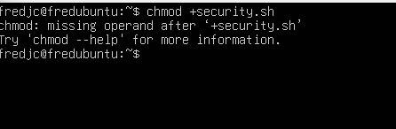

It said permission denied because I forgot to add the operand x in it.
Command use : ./security.sh
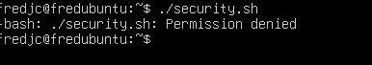

Improvement in command
Command use : chmod +x security.sh
./security.sh

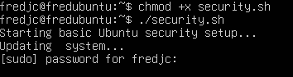

After entering passwords, it updates.
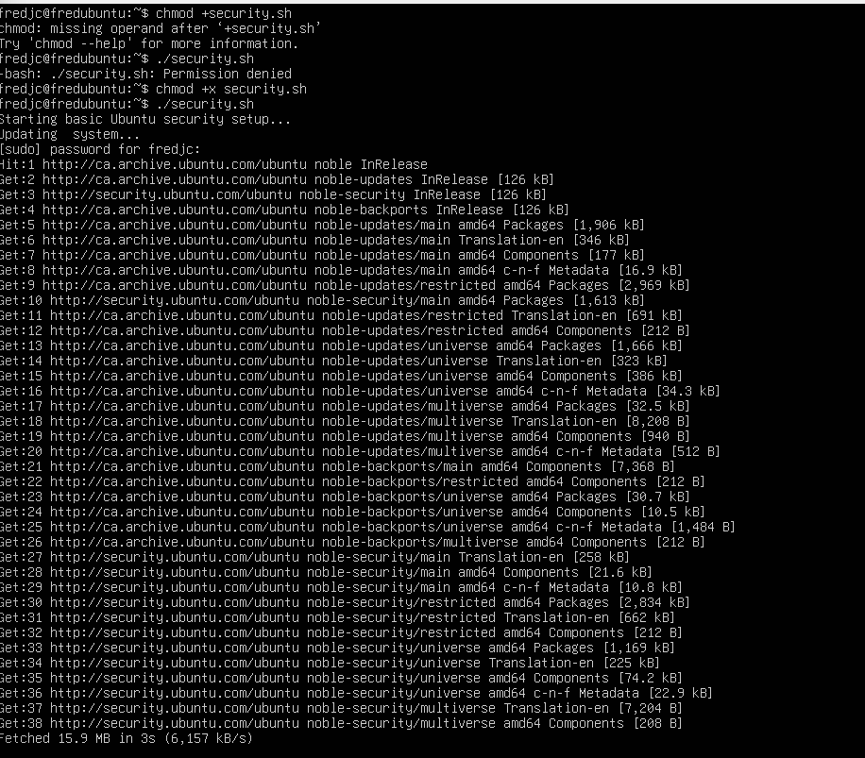

Still in progress
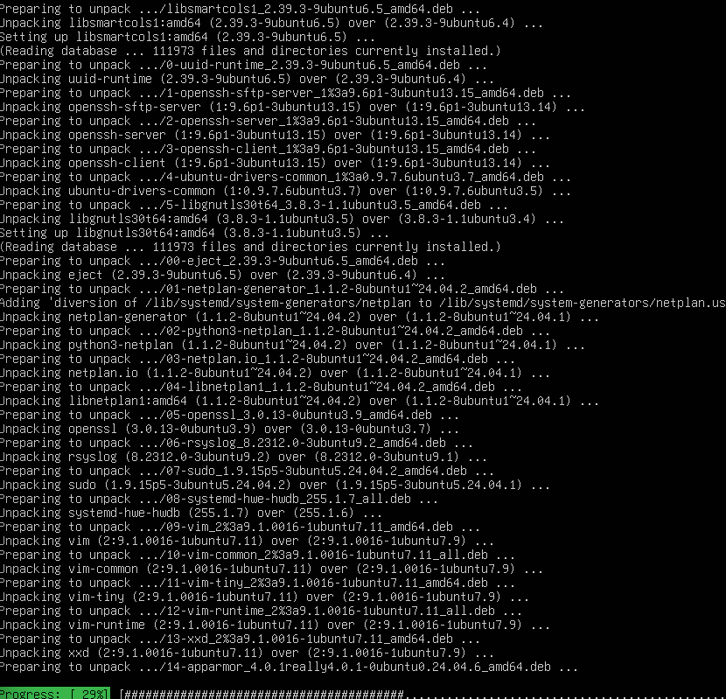

Prompt this screen after the process is complete
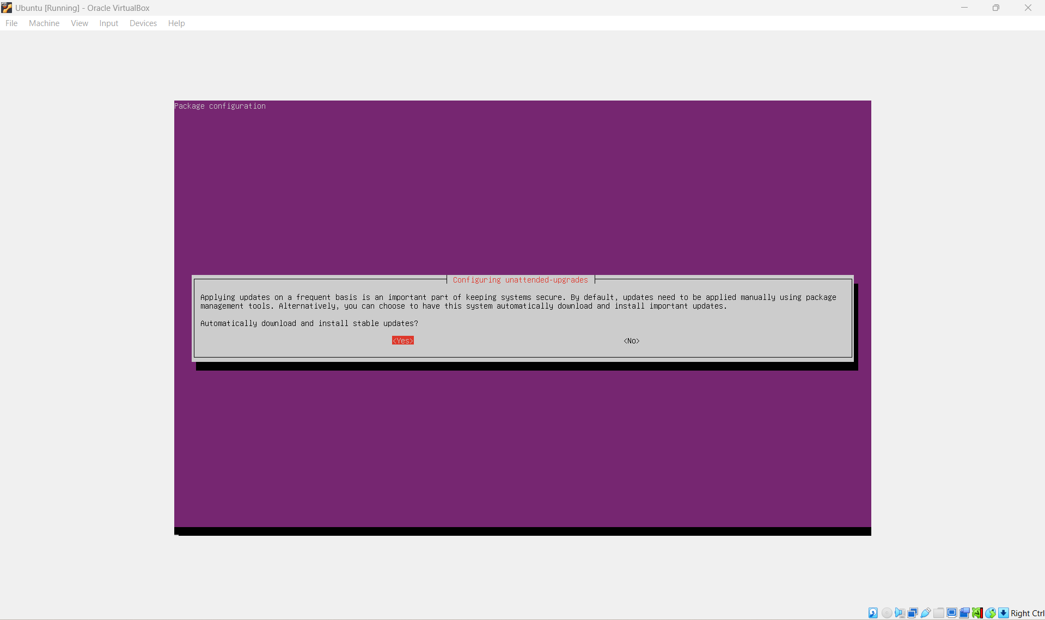

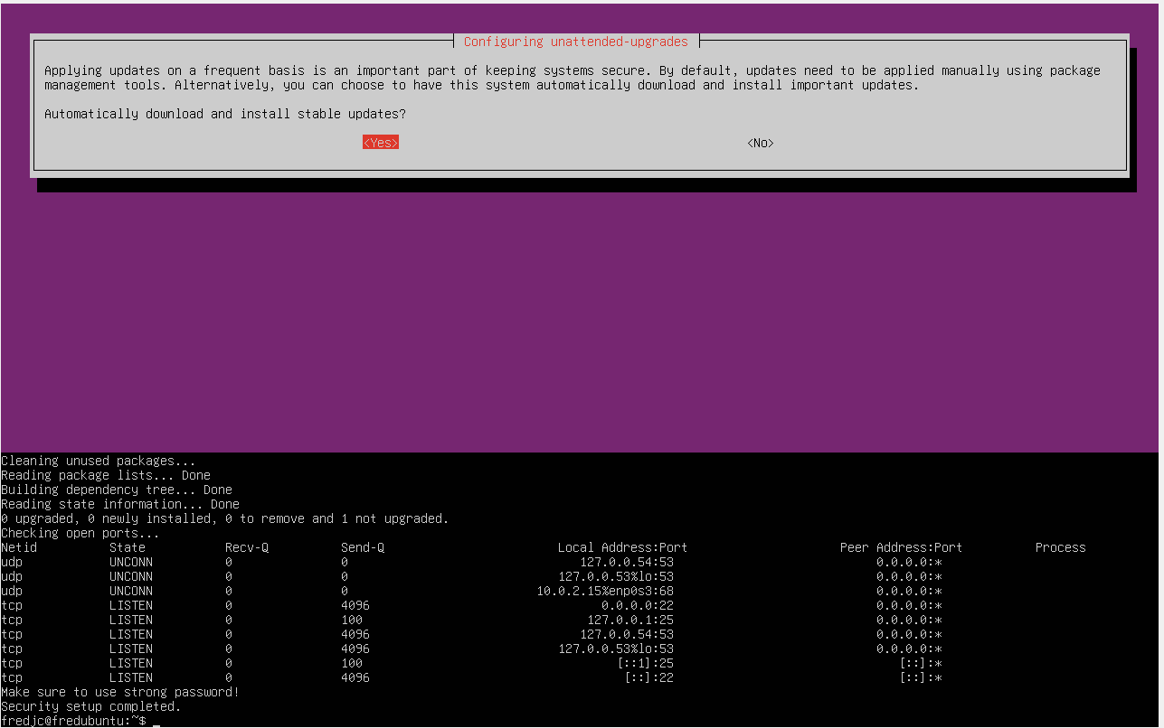
I successfully executed the script and verified that the firewall rules were applied, SSH port and some necessary ports are still open. Furthermore, the system has no pending updates. The script was completely correct without errors.

What was done by me ?
The Script created by the AI did not need changes. However, I discovered a issue while testing it with dpkg-reconfigure unattended-upgrades command. This command opened an interactive menu. This causes the script to stop and ask for manual input. I did select the correct option which was yes. The script was not fully automated. Therefore I had to make that modification myself.

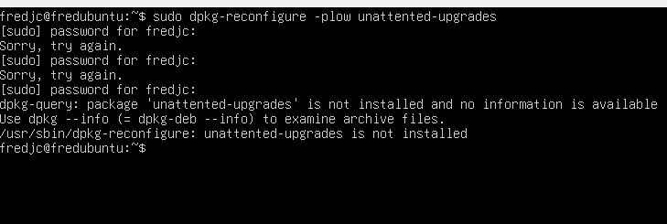
While testing, I ran the dpkg-reconfigure unattended-upgrades command, and I got an error saying that the package was not installed. It means the package should be installed before configuration. So now I have to do this manually.

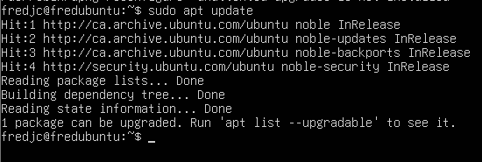
Command use : sudo apt update

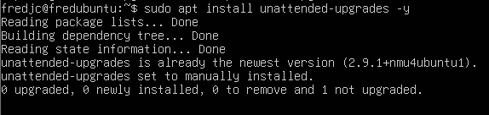
Command use : sudo apt install unattended-upgrades -y

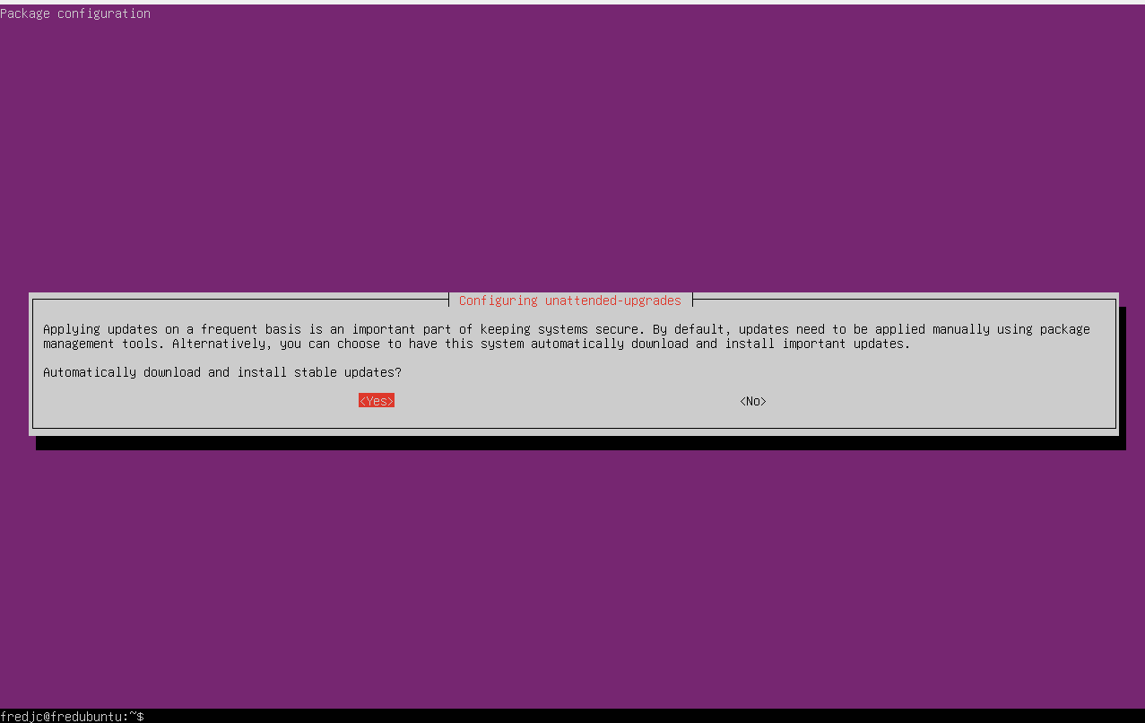
After entering the command sudo dpkg-reconfigure unattented-upgrades. I got this screen back. I just press enter while choosing yes, which means the configuration is working correctly now.

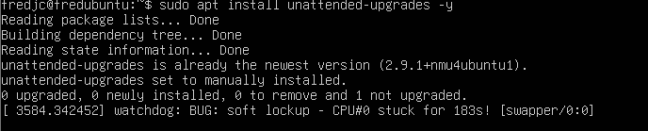
However, during testing, I encountered this issue. A system warning about soft lockup. It means my CPU was not responsive for a while. This was nothing to do with the script since the installation was still successful. It was a problem related to virtual machines directly.

Verify firewalls
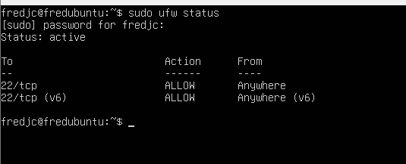
Command use : sudo ufw status
This shows that firewalls is active and successfully enabled. Also, SSH access is allowed from anywhere. The same thing is applied for IP6 version. Not any connections are allowed. It reduces unauthorized access.

Verify fail2ban
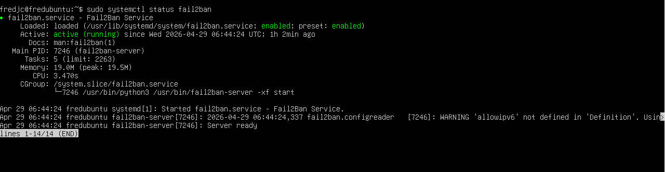
The Fail2Ban service was checked using the sudo systemctl status fail2ban command. The output shows that it is running and enabled. This means Fail2Ban is working correctly. It also helps protect the system by blocking suspicious login attempts.

The ubuntu security script was run and tested successfully. It goal was to improve system security by automating tasks like updates, firewall setup, and protection against attacks.
The script updated the system, installed and enabled firewall, and blocked all incoming connections except SSH. This was confirmed using the sudo ufw status command, which showed the firewall was active and only port 22 was allowed.
It also installed and started Fail2ban, which helps protect the system by blocking repeated failed login attempts.
Automatic updates were set up using unattended upgrades, but this step required manual input during trsting. This showed that the script is not fully automated and could be improved.
Some issues happened during testing. At first, there was a permission error, which was fixed using chmod+x. The unattended-upgrades setup required using TAB and ENTER to continue. A soft lockup warning also appeared, which was caused by the virtual machine’s performance not the script. The script also removes unused packages and checked open ports to show active services.

AI summary of conversation
My first prompt was : Provide security script for ubuntu
The AI responds : I will give me a clean script plus short explanations so you can learn ( not just copy)
I gave this script with step-by-step explanation

#!/bin/bash

echo "Starting basic Ubuntu security setup..."

# -------------------------------
# 1. Update and upgrade system
# -------------------------------
echo "Updating system..."
sudo apt update && sudo apt upgrade -y

# -------------------------------
# 2. Enable firewall (UFW)
# -------------------------------
echo "Configuring firewall..."
sudo apt install ufw -y
sudo ufw default deny incoming
sudo ufw default allow outgoing

# Allow SSH (important so you don’t get locked out)
sudo ufw allow ssh

# Enable firewall
sudo ufw enable

# -------------------------------
# 3. Install Fail2Ban (brute force protection)
# -------------------------------
echo "Installing Fail2Ban..."
sudo apt install fail2ban -y
sudo systemctl enable fail2ban
sudo systemctl start fail2ban

# -------------------------------
# 4. Automatic security updates
# -------------------------------
echo "Installing unattended upgrades..."
sudo apt install unattended-upgrades -y
sudo dpkg-reconfigure -plow unattended-upgrades

# -------------------------------
# 5. Remove unused packages
# -------------------------------
echo "Cleaning unused packages..."
sudo apt autoremove -y

# -------------------------------
# 6. Check open ports
# -------------------------------
echo "Checking open ports..."
sudo ss -tuln

# -------------------------------
# 7. Basic password policy reminder
# -------------------------------
echo "Make sure to use strong passwords!"

echo "Security setup completed."

What This Script Actually Does (Important for your understanding)
1. System Updates
- Fixes vulnerabilities
- Most important step in security
2. Firewall (UFW)
- Blocks unwanted traffic
- Keeps SSH open (so you don’t break remote access)
👉 This is where your earlier issue came from — removing SSH rules = locked server

3. Fail2Ban
- Protects against brute-force attacks
- Automatically bans suspicious IPs

4. Automatic Updates
- Keeps your system patched without manual work

5. Cleanup
- Removes unused packages (reduces attack surface)

6. Port Check
- Shows what services are exposed

⚠️ What I Intentionally DID NOT include (and why)
I left out:
- SSH config hardening (can break access)
- disabling root login (risky if misconfigured)
- aggressive permissions changes
- intrusion detection tools (too advanced for now)
👉 Because your goal (based on your course work) is:
safe + understandable + explainable

However, it took me three attempts to make it run on the server
First, I ran it but I had permission denied because I forgot the operand x
Second attempt the script start running and stop at the unattended-upgrades configuration step. It opens a screen that requires manual input.
The last attempt I had to start over with the process and select YES. Therefore, the Script run successfully and completely.

Here is the screenshort once again.


